Form: Dance Dynamics Release from Liability, Waiver of Claims & Assumption of Risk  Parties, Clinics, Events, Classes | 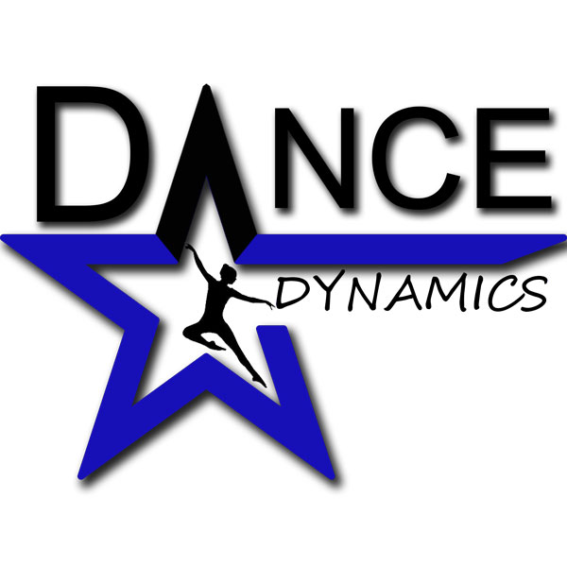

RELEASE FROM LIABILITY, WAIVER OF CLAIMS & ASSUMPTION OF RISK
Last Name |  |  |  |  | First |  |  |  | Date
Street Address |  |  |  |  |  |  |  |  | Apartment/Unit #
City |  |  |  |  | State |  |  |  | ZIP
Phone |  |  |  |  | E-mail Address
I, on behalf of myself, my heirs, executors, agents, assigns, and representatives, hereby indemnify, release and forever hold harmless Dance Dynamics as well as its directors, employees and instructors, from any and all claims of liability arising from any accident, personal injury, death, or property loss or damage sustained by my child/myself/the minor child for whom I am a legal guardian, while that person is participating in activities connected with Dance Dynamics, including Dance and Acro/Tumble Clinics dance classes, rehearsals, performances, parties, camps, bouncy house parties, activities and events. I understand that dance activities have inherent risks of injury, and, being fully aware of all risks, I consent to have my child/myself/the minor child for whom I am a legal guardian, participate in the programs and activities offered by Dance Dynamics. I accept full responsibility for providing adequate health and accident insurance coverage for the protection of all of the following who participate in these programs/activities: my child/myself/the minor child for whom I am a legal guardian. By signing this statement, I declare that the aforesaid participant is in good health, with no physical conditions that might prevent his/her/my participation in Dance and Acro/Tumble class and clinics, dance classes, rehearsals, performances, parties, camps, events, bouncy house parties or other activities at Dance Dynamics.

Further, I understand and acknowledge that because of the physical nature of dance and all activities named above, there may be physical contact between instructors and students during classes or other activities. I understand that at times, for proper instruction and safety, physical contact is required and necessary.

I have carefully read this Waiver, Release, & Assumption of Risk and fully understand its contents. I understand that this is an assumption of risk and release of liability, and I sign it of my own free will.

ACCEPTED BY
Print Parent/Guardian Full Name
Signature Parent/Guardian
Print Student/Child Name
Date

